Task 12 Sc Inq 4 Part 1
DNA sequencing by gel electrophoresis Total 20M

The gel electrophoresis method was developed in the late 1960's. It is a fundamental tool for DNA sequencing.
The gel is inserted horizontally or vertically (depending on the design of the apparatus) into the electrophoresis chamber and covered with buffer. Samples containing DNA mixed with loading buffer (which contains something dense, eg glycerol to allow the sample to "fall" into the sample wells, and one or two tracking dyes to allow visual monitoring) are then pipetted into the sample wells, the lid and power leads are placed on the apparatus, and a voltage of no more than 5 volts per cm is applied (the cm value is the distance between the two electrodes).
In the electrophoresis buffer the DNA dissociates into a negatively charged moiety and a hydrogen ion. Thus the DNA anion will migrate toward the positive electrode. Since the DNA molecules have to wiggle through the microscopic meshes within the gel (called viscosity in physics), the rate of migration depends on their length - the shorter one moves faster, i.e., the mobility is inversely proportional to the log₁₀ of the molecular weight. Now the DNA fragments of different size have been separated into groups as shown below. This is an important step toward DNA sequencing, but the identity of the DNA is still unknown.
The great length of DNA molecules was the main stumbling block that prevented its sequencing. The problem was resolved by the discovery that bacteria use an enzyme to restrict infection by certain bacteriophages - hence the term restriction enzyme. The restriction enzymes are since used to cut whole piece of DNA into fragments (see below). Specifically, there are enzymes to cut DNA precisely after an adenosine nucleotide (A) or T, or G, or C.

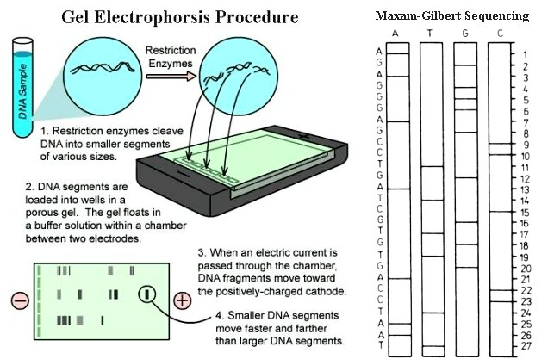

The Maxam-Gilbert method of DNA sequencing separates the DNA sample into four groups each one treated with a specific restriction enzyme for A, T, G, or C. After this, all four groups are placed in the same apparatus for gel electrophoresis. The resulting DNA sequence is shown above. The process can be automated by attaching different fluorescent dye to the end of the DNA fragments in each group and read off by a scanning detector hooking up to a computer
Adapted from http://universe-review.ca/R11-16-DNAsequencing.htm
1. Read the article above, and then answer these questions.

- When was gel electrophoresis developed? (1m)
_________________________________________________________________________
- What does it involve? (2m)
__________________________________________________________________________________________________________________________________________________
- How do we break the DNA into fragments? (1m)
_________________________________________________________________________
- Which method separates the fragments into 4 groups? (1m)
_________________________________________________________________________
- How can this process be automated? (1m)
_________________________________________________________________________

2. Reading a gel sequence

The diagram below shows how the gel can be read to get a DNA sequence

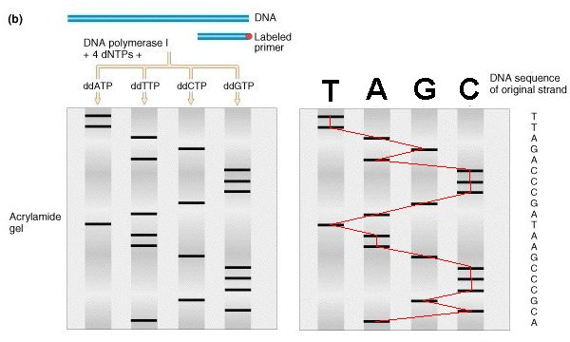
Figure © 2000 by Griffiths et al ; text © 2006 by Steven M. Carr

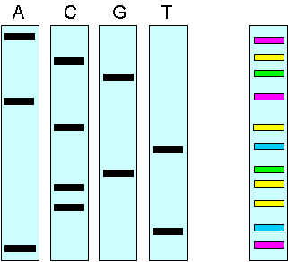

a) What DNA sequence is shown here? (2m)
______________________________________________
b) What DNA sequence is shown here for each of the four plates below? (4m)

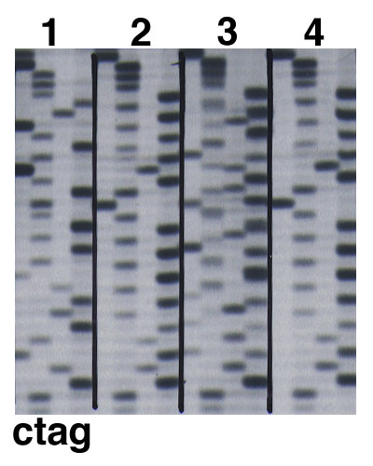

Plate 1 ____________________________________________________________________________
Plate 2 ____________________________________________________________________________

Plate 3 ____________________________________________________________________________
Plate 4____________________________________________________________________________

Sometimes we don’t need to know the actual DNA sequence, but can use restriction enzymes to isolate a particular gene or section of DNA associated with an inherited disorder or trait that is being investigated.

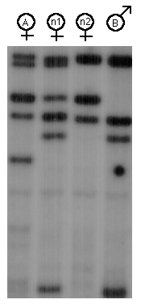
c) Individuals A and N2 show symptoms of a disease caused by a genetic defect. The fragment associated with the disease is shown by the arrow.

- Is B likely to have this disease? _____ (1M)
- N1 has no symptoms of the disease. Is she free of the gene? _____________________ (1M)
- What do we call people with a gene for a disease, who do not show the symptoms of the disease? _________________________________(1M)

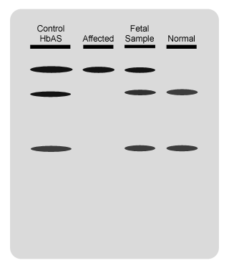
d) The samples opposite show the DNA test of an embryo suspected of having sickle cell anaemia.

The control HbAS sample is from the mother who has both normal and affected genes.

The affected sample shows the DNA of a person who has 2 affected genes.

The normal sample shows the DNA of a person who has 2 normal genes.

What genes does the embryo have?

e) DNA sequencing is being used for other purposes besides identification of inherited disorders. Describe one other use for this technique, and explain why it is used this way. (5M)
_____________________________________________________________________________________________________________________________________________________________________________________________________________________________________________________________________________________________________________________________________________________________________________

